Buildroot - Adding Bluetooth to raspberry pi 3
With Qt5 rpi-userland

This document will build an image for raspberry pi 3 with Qt , open gl and bluetooth support.
I am using Qt5 rpi-userland and not the mesa drivers
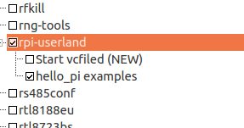

in a previous document I explained how I enable the open gl es for embedded system using the gallium vc4 mesa driver and the device tree overlay.

I appears that there are two options, once using eglfs-kms and using eglfs-brcm integration with rpi-userland.

As for now , the mesa driver buildroot setup works better and I can run any exapmple, from the easy one to the complex one (maroon and so)
rpi-userland works but I an getting as for now Bus error on maroon and some other exmaples.

Like in all the QT documents I am adding at the end my summery of compiling QT program from QT creator using buildroot environment from the command line.
Using Qt Creator completely does not work for me yet in QT5 ( QT4 works)

Enable rpi-bt-firmware
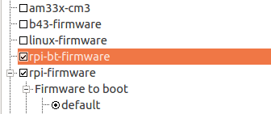

just search for it , it is faster then telling where it is.
In xconfig press ctrl+f
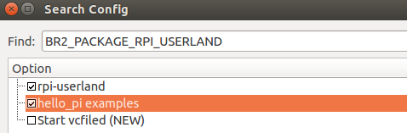

Add udev:





Two versions of bluez we have in buildroot

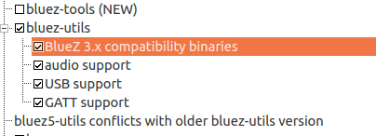

the bluez5 is for kernel 3.5 and higher:

bluez utils version 5.x

With this release BlueZ only supports the new Bluetooth
Management kernel interface (introduced in Linux 3.4).

For Low Energy support at least kernel version 3.5 is
needed.

BlueZ is a library without official documentations and without much help from the owners.

The dummy backend is also selected on Linux if BlueZ development headers are not found during build time or Qt was built without Qt D-Bus support.

That's mean that we need BlueZ and D-bus ( Qt5 module)



https://code.google.com/archive/p/bluez-tools/

install that in buildroot


The list of tools is listed in the above link.
After adding this to buildroot image.
It can be found in the raspberry pi 3 at:
/usr/bin

some if the list:

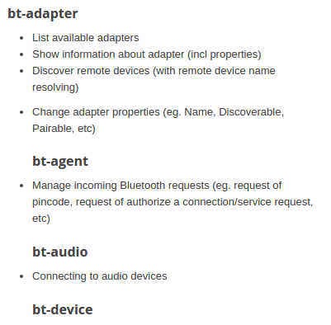

The Bluetooth HCI kernel module (dynamic device driver)

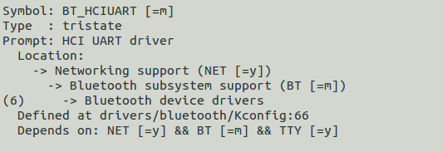

in the raspberry pi 3 after deploying the image, the driver can be found there:
/lib/modules/4.9.21-v7/kernel/drivers/bluetooth

hci_uart.ko

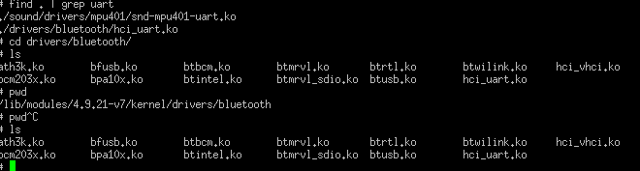
the hci_uart is a kernel module that should be loaded:
modeprobe btusb
modprobe hci_uart

the modprobe will load the driver with all its dependencies.

After loading I see in /var/log/messages:

1 00:00:03 buildroot user.notice kernel: [ 0.000000] Kernel command line: 8250.nr_uarts=1 bcm2708_fb.fbwidth=1920 bcm2708_fb.fbheight=1080 bcm2708_fb.fbswap=1 vc_mem.mem_base=0x3dc00000 vc_mem.mem_size=0x3f000000 root=/dev/mmcblk0p2 rootwait console=tty1 console=t
Jan 1 00:00:03 buildroot user.info kernel: [ 0.086683] uart-pl011 3f201000.serial: could not find pctldev for node /soc/gpio@7e200000/uart0_pins, deferring probe
Jan 1 00:00:03 buildroot user.err kernel: [ 0.341481] bcm2835-aux-uart 3f215040.serial: could not get clk: -517
Jan 1 00:01:29 buildroot user.info kernel: [ 89.404744] uart-pl011 3f201000.serial: no DMA platform data
Jan 1 01:05:20 buildroot user.warn kernel: [ 3920.642468] hci_uart: Unknown symbol btbcm_finalize (err 0)
Jan 1 01:05:20 buildroot user.warn kernel: [ 3920.663126] hci_uart: Unknown symbol btbcm_initialize (err 0)
Jan 1 01:05:20 buildroot user.warn kernel: [ 3920.684171] hci_uart: Unknown symbol btbcm_set_bdaddr (err 0)
Jan 1 01:05:20 buildroot user.warn kernel: [ 3920.704782] hci_uart: Unknown symbol btbcm_check_bdaddr (err 0)
Jan 1 01:05:20 buildroot user.warn kernel: [ 3920.725749] hci_uart: Unknown symbol btbcm_patchram (err 0)

This is the output of lsmod after I loaded the two drivers modules btusb and hci_uart
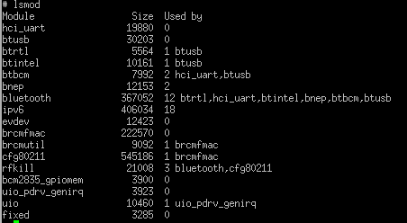

still no hci device in /dev
hcitool dev
Device: ( no devices)

The main problem is involved with:

The /dev/ttyAMA0 previously used to access the UART now connects to Bluetooth.
The miniUART is now available on /dev/ttyS0

This is the raspbian cmdline.txt:
dwc_otg.lpm_enable=0 console=serial0,115200 console=tty1 root=PARTUUID=94916e5f-02 rootfstype=ext4 elevator=deadline fsck.repair=yes rootwait quiet splash plymouth.ignore-serial-consoles

root=/dev/mmcblk0p2 rootwait console=tty1 console=ttyS0,115200

Note- console=tty1 is the console that dumps the boot to screen.
This conflicts with the serial input.
Removing it , will have input console working fine but not printing on screen

remove this line from the script: --add-pi3-miniuart-bt-overlay

Blueman
Blueman is a full featured Bluetooth manager written in GTK+.
We don't have blueman because we don't have X window or gtk+ installed.

At the beginning I installed bluez5-utils
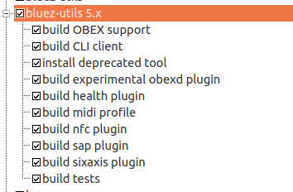

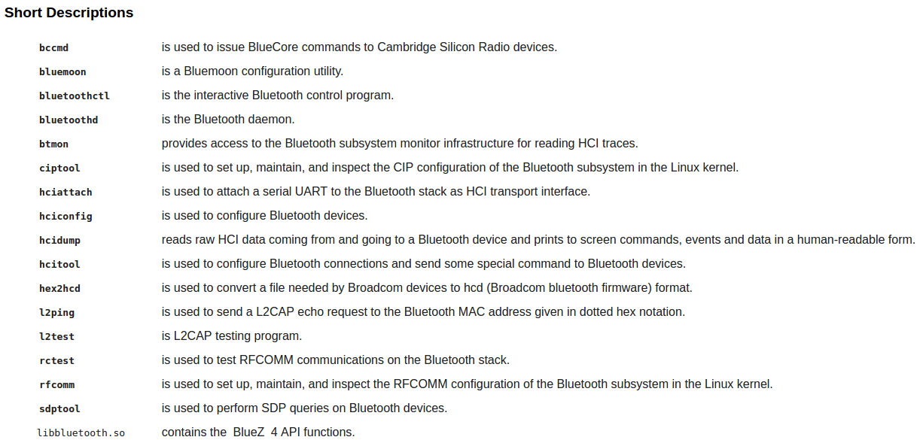

Not all the above tools are exist in the target raspberry pi 3.
for example , hciconfig, hciattach , rfcomm, sdptool.

After installing the bluez-utils version 3.

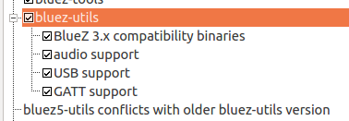

I got hcitool in /usr/bin and hciconfig in /usr/sbin.

Most of the help in the INTERNET are referring to the bluez 3 with hcitool and hciconfig.

So lets start with that:

So I found several tutorials about bluez 3 , one of them:
https://fixmynix.com/bluetooth-in-linux-with-bluez-and-hcitool/

This tutorial use Linux OS but because our image now should contains raspberry pi 3 bluetooth firmware + bluez 3 and bluez-tools we can check that out:

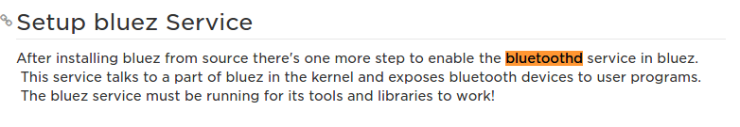
First of all , we need to run the daemon service:
bluetoothd

It is not running automatic at start.
Can be added to /etc/init.d/S60bt
as a script there for the rcS

Only when we run it the bluetooth driver will run.
We can see the bluetooth module driver before and after the bluetoothd with
lsmod

on the raspberry pi 3 I type:
hciconfig hci0 up
No such device

bt-atapter -l
got:
No adapter found

Install rfkill from busybox
make busybox-menuconfig
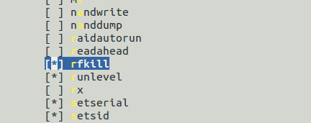

build the image again and deploy to raspberry pi 3
rfkill - tool for enabling and disabling wireless devices

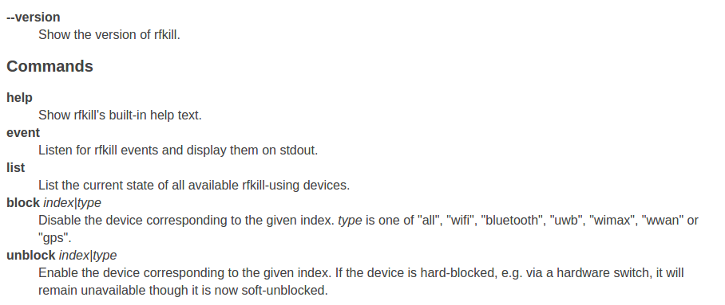

rfkill list
or
rfkill list all
just shows the phy0: wlan

following this
https://askubuntu.com/questions/383442/bluetooth-not-turning-on

The raspberry pi 3 does not list the bluetooth in rfkill list

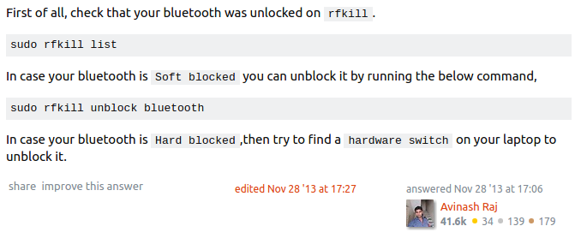
Up to now , no success
hcitool dev on the raspberry pi 3 return Device: ( nothing in the list)

in my ubunto I do see the hci bluetooth with rfkill list

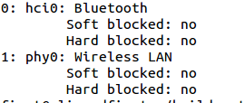

Ok,
Following this:

http://lifehacker.com/everything-you-need-to-set-up-bluetooth-on-the-raspberr-1768482065

bluetoothctl

Is a tool with various commands.

Trying:
power on

raspberry pi 3 answer:
No default controller availble

Continue:

The raspberry pi 3 git repository for the bluetooth firmware is here:

https://aur.archlinux.org/packages/pi-bluetooth

After extracting:

-rw-rw-r-- 1 first first 113 Jun 13 08:28 50-bluetooth-hci-auto-poweron.rules
-rw-rw-r-- 1 first first 35976 Jun 13 08:28 BCM43430A1.hcd
-rw-rw-r-- 1 first first 305 Jun 13 08:28 brcm43438.service
-rw-rw-r-- 1 first first 4178 Jun 13 08:28 LICENCE.broadcom_bcm43xx
-rw-rw-r-- 1 first first 76 Jun 13 08:28 pi-bluetooth.install
-rw-rw-r-- 1 first first 1031 Jun 13 08:28 PKGBUILD

I can see the file BCM43430A1.hcd in my raspberry pi 3 at /lib/firmware
that's mean that buildroot , by checking rpi-bt-firware , add this file to the rootfs.

Continue .

Found this:

https://wiki.alpinelinux.org/wiki/Raspberry_Pi_3_-_Setting_Up_Bluetooth

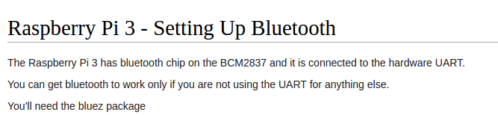

As it suggested there , I removed the
"console=ttyAMA0,115200"

and replace it with
console=ttyS0,115200

from
./output/images/rpi-firmware/cmdline.txt

the new line there is now:
root=/dev/mmcblk0p2 rootwait console=tty1 console=ttyS0,115200 cmd=256M

run:
hciattach /dev/ttyAMA0 bcm43xx 115200 noflow -

still getting:

unknown device type or id

switching back to bluez 5
I need to so make clean , because for now I dont know how to remove packages from buildroot once it was added. Remove it in the menuconfig does not really remove or replace the packages

lastly , I post a question in stack overflow:

https://stackoverflow.com/questions/44554255/bcm43xx-init-initialization-timed-out-with-buildroot-raspberry-pi-3-hciattach/44564073#44564073

And after a day I got answer:

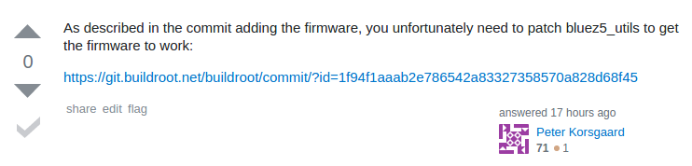

The patch needed according to – Peter Korsgaard

https://www.spinics.net/lists/linux-bluetooth/msg69470.html

So I have added it into:

The sleep after the firmware download

rebuild the package:

if I will do make clean buildroot will extract again the bluez5 utils and my change will lost
I need to recompile a packages
http://free-electrons.com/~thomas/buildroot/manual/html/ch05.html

When changing the file or even doing make clean in the bluez5 directory it does not trigger buildroot
only the above , remove the .stamp_built
in the bluez5 utils directory.

To make the bluetooth discoverable:
hciconfig hci0 piscan

QT5

In my QT 5 open EGLFS VC4 on raspberry pi 3 , I show how to enable QT5 with open GL drm driver the VC4 driver

There are two options
1. Using mesa driver VC4 Galilum driver
2. using raspberry pi userland

The first one I cover in a different document and youtube video
The second one , using raspberry pi 3 userland require some care:

First , I don't need the overlay in this mode:

https://stackoverflow.com/questions/40490113/eglfs-on-raspberry2-failed-to-add-service-already-
in-use

It is already loaded with the rpi userland.
As we can see , in buildroot , no mesa at all
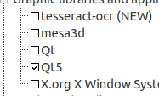

Qt5:
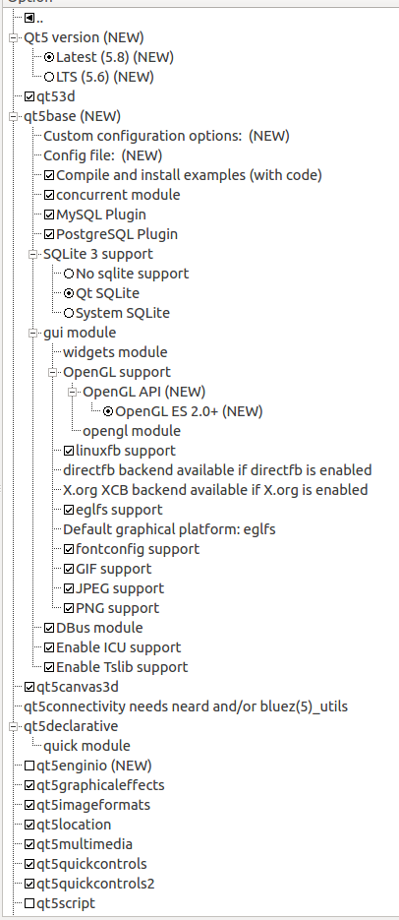

Some notes:
1. The device integration when using rpi userland is eglfs-brcm and not eglfs-kms
2. we don't need the overlay in rpi-firmware/config.txt
3. add cma=256M in cmdline.txt
output/images/rpi-firmware/cmdline.txt

The profile in output/target/etc/profile should be:

export QT_QPA_FONTDIR=/usr/share/fonts/dejavu
export QT_QPA_ENABLE_TERMINAL_KEYBOARD=1
export QT_QPA_EGLFS_INTEGRATION=eglfs_brcm
export QT_LOGGING_RULES=qt.qpa.*=true
export QT_QPA_PLATFORM=eglfs
export QT_QPA_EGLFS_PHYSICAL_WIDTH=100
export QT_QPA_EGLFS_PHYSICAL_HEIGHT=100
#export QT_IMPORT_TRACE=0

note that QT_QPA_EGLFS_INTEGRATION is eglfs_brcm and not eglfs_kms
actually QT will find it by it self.

The overlay we add with the mesa vc4 driver, we don't need it here
dtoverlay=vc4-kms-v3d
otherwise we will get device in use.

I tried to run quickcontrol2 gallery example and it works.
But for now the maroon example and some other throw bus error.

Testing qt quickcontrol2 example:
On Ubuntu first:
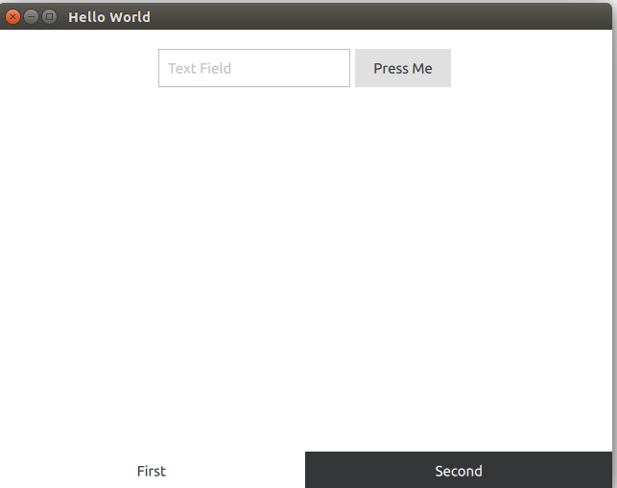

using 3 scripts:

ACTIVATE.sh:
export PATH=$PATH:/home/first/buildroot/blrpi3_32/buildroot-2017.05/output/host/usr/bin

compile:
/home/first/buildroot/blrpi3_32/buildroot-2017.05/output/host/usr/bin/qmake $1 -spec /home/first/Qt/5.9/Src/qtbase/mkspecs/arm-linux-gnueabihf-g++ CONFIG+=debug CONFIG+=qml_debug

replace:
make
sudo sshpass -p "thepassword here" scp $1 root@10.0.0.11:/home

note that for the first time you need to do sudo scp without the sshpass
to let scp set the keys.

Result:
This example works on the raspberry pi 3 ( no bus error)

But without a keyboard:

Adding:


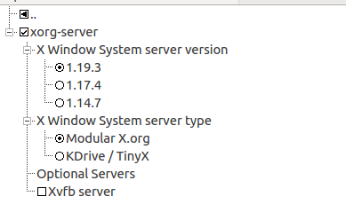



Does it help?

YES , we have now keyboard.

Conclusion:

I don't know from where the bus error happened.
I read it could be because of the floating point hardware alignment,
but remembrancer , in eglfs-kms with mesa vc4 driver it does not happened.

If we choose to work with the userland for egl then it will probably be found durring development.

Rpi-userland is supporting several API:
EGL, mmal, GLESv2, vcos, openmaxil, vchiq_arm, bcm_host, WFC, OpenVG.

The EGL for now is not behave the same as the mesa 3d EGL.

libmount
The libmount library is used to parse /etc/fstab, /etc/mtab and /proc/self/mountinfo files, manage the mtab file, evaluate mount options, etc.
The library is part of the util-linux package since version 2.18
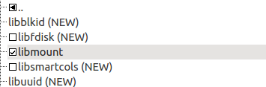

Qt creator:

I am following:
http://doc.qt.io/qt-5/qtbluetooth-qmlmodule.html
http://doc.qt.io/qt-5/qtbluetooth-scanner-example.html

Summery of compiling QT 5 in command line

After we created a buildroot image , with QT5
we have two thing we need:

1. Compiler
2. Sysroot

Create a project in Qt Creator.

Open command terminal
and create two scripts files

1. ACTIVATE.sh for adding the path of the buildroot compilers

export PATH=$PATH:/home/first/buildroot/blrpi3_32/buildroot-2017.05/output/host/usr/bin

2. compile script

/home/first/buildroot/blrpi3_32/buildroot-2017.05/output/host/usr/bin/qmake $1 -spec /home/first/Qt/5.9/Src/qtbase/mkspecs/arm-linux-gnueabihf-g++ CONFIG+=debug CONFIG+=qml_debug

The compile script run buildroot qmake

we need to specify:
1. full path of the qmake in buildroot

2. the full path of the mkspecs

If we are not working inside the QT SRC the qmake will not know where the mkspcs.

The mkspec need to be created, in most cases it is not exist.
So copy from one of the arm-linux-unkonwn... using cp-r

and change all the compiler name to the buildroot compiler name

arm-linux-gnueabihf

The result of the new mkspec qmake.conf files should be:

#
# qmake configuration for building with arm-linux-gnueabihf-g++
#

MAKEFILE_GENERATOR = UNIX
CONFIG += incremental
QMAKE_INCREMENTAL_STYLE = sublib

include(../common/linux.conf)
include(../common/gcc-base-unix.conf)
include(../common/g++-unix.conf)

# modifications to g++.conf
QMAKE_CC = arm-linux-gnueabihf-gcc
QMAKE_CXX = arm-linux-gnueabihf-g++
QMAKE_LINK = arm-linux-gnueabihf-g++
QMAKE_LINK_SHLIB = arm-linux-gnueabihf-g++

# modifications to linux.conf
QMAKE_AR = arm-linux-gnueabihf-ar cqs
QMAKE_OBJCOPY = arm-linux-gnueabihf-objcopy
QMAKE_NM = arm-linux-gnueabihf-nm -P
QMAKE_STRIP = arm-linux-gnueabihf-strip
load(qt_config)

running compile script (which rans qmake with the cross compiler)
will generate make files for us

run
make
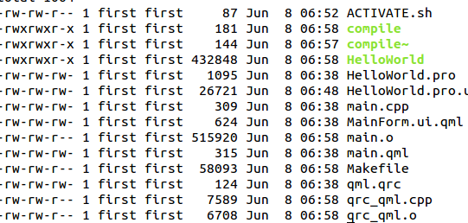

And the HelloWorld will be ready to transfer to target using SCP

